Impressionism Project
Name
Course
Instructor
Institution affiliation
Date

Impressionism is a movement of painting with its origin believed to be France in the 1870s. The artwork went against the presiding artwork guided by beaux-arts, which refers to fine art. The artists behind the work came up with a new way of perceiving and illustrating the universe in their work, preceding the realistic portrayals for a fleeting impression of their surroundings, which was often found outside. Impressionists went against the norm of painting in a studio. Instead, they preferred working in the open air in front of their subjects to capture the sunlight's momentary and transient effects. Therefore, Impressionism gave birth to the awareness of light and color and the shifting pattern of the natural scene.

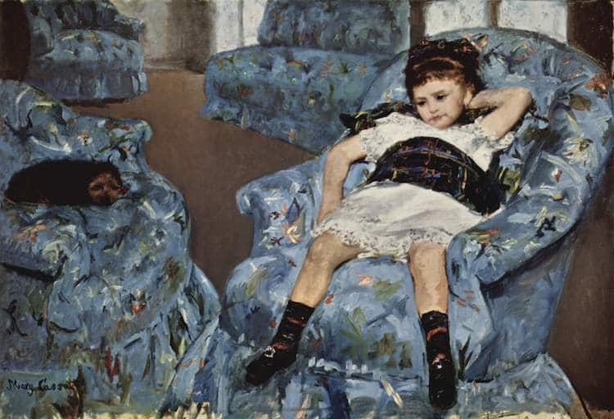The little girl in a blue armchair by Marry Cassatt, 1878,
The painting was a testament to Marry Cassatt and Impressionism and her acceptance of a freer painting style. With a limited palette and vibrant brushstroke, she created a dynamic interplay of forms echoed in this captured moment between resting and playing. The painter manages to ensure that every object in the room is seen differently by using the light that illuminated the room through the French doors in the background. The tilted picture plane makes it possible for the audience to notice the haphazardly arranged four large, blue chairs and the brownish-grey floor, which is seen in between them. By painting the floor with energetic brushwork makes sure that life is given to it.
Furthermore, the girl is also seen to be flopped on a chair in what seems to be a moment of boredom or exhaustion while the dog, on the other hand, lying on one of the blue chairs in a state of utter repose. The painting can be said to have been a successful work of Impressionism because every object in it was able to communicate independently even though it was not done in a studio. People in the modern-day society can relate to the painting even though it was done so many years down the line. As we have seen, the girl's posture shows that she was either tired or bored. The dog lying on the other chair could mean that it was either afraid of the girl or exhausted from playing with the same girl outside the house before coming in and resting.
The haphazard way in which the chairs are arranged can also represent the playful nature of the girl. In most families with little children, chair arrangements are important things that visitors or any other person could tell of their playful nature. The color of the chairs, on the other hand, could be the favorite color of the girl. The chairs' position and the chairs prove that the painting was impressionist of which it was done in an unplanned manner, yet it gave us the right impression as could not have been the case in the studio where things are organized and controlled.

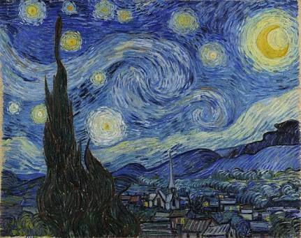
The starry night by Vincent Van Gogh, 1889
Although some critics may argue that the landscape painting was done during the day in the van Gogh ground floor, it will be inaccurate to say that the picture was made from his memory. The picture's view has been identified as one from his bedroom windows facing east, of which van Gogh painted variations of no fewer than twenty-one times, which included the starry night. In his letter to his brother Theo, he says, “ through the iron-barred window, I can see an enclosed square of wheat above which, in the morning, I watch the sun rise in all its glory.”
While in the hospital, he was not allowed to paint in his bedroom. At this point, he had to make sketches in ink or charcoal on paper, which gave his previous paintings different variations. The pictorial element that united all of the paintings is the diagonal line coming in from the right, which depicted the Alpilles mountains' low rolling hills. Cypress trees are also visible in the painting beyond the far wall enclosing the wheat field.
From the landscape painting, I think it has been used as a means of conveying emotions. Many people feel that Van Gogh's turbulent quest to overcome his illness is reflected in the night sky's dimness. Furthermore, the village is painted with dark colors, but the brightly lit windows create a sense of comfort. The peaceful appearance of the village and the dramatic representation of the night sky can be felt through the painting. The steeple dominates the village and symbolizes unity in the town.
Moreover, the church steeple gives an impression of size and isolation. There has been quite a lot of debate about van Gogh's choice of color in this particular painting and much more before this. He used yellow as a dominant color, which seems to be weird. Some people argue that he may be suffering from lead poisoning or brain disease, which explains the strange choice of colors.

